The American Dream for Boston Public School Teachers

Amir Elhelw, Emily Dishian, Dimitar Ivanov, and Kamil Pacana

Northeastern University, Boston, MA, USA

Abstract

We investigated the question of whether Boston public school teachers could attain the American dream within Boston. We defined the American Dream as the ability to purchase a single-family home within the city with the average teacher’s salary. To determine affordability, we used a rough estimate that someone with good credit can afford to buy a house that ideally is no more than three times their annual pre-tax salary, and (under the very best circumstances) can afford to buy a house up to five times their annual pre-tax salary [1, 2]. We investigated this question using publicly available data on Boston city government employee earnings and Boston property values from data.boston.gov [3, 4].

Our goal was to understand how public school teachers’ salaries and the price of single-family homes have been changing over time in relation to one another to determine if teachers are being priced out of buying a home in the city. Additionally, we aimed to predict how these trends will evolve into the future.

Through our data analysis, we discovered that since about 2013 the average teacher cannot realistically purchase a home in the city with their salary, with the situation worsening until our most recent data from 2022. We found that during this time, teachers have been priced out of almost all Boston neighborhoods and, according to our calculations, we expect this situation to continue to worsen. Simply put, while teachers’ salaries have, on average, increased from 2011 to 2022, the cost of single-family homes has increased much faster.

Introduction

The American Dream embodies a promise made to countless generations of Americans: the potential for a fulfilling life achievable through hard work. While the specific interpretation of this dream varies among individuals, one of its hallmark classical ideals is owning a single-family home of one’s own. Yet with the countless cries we’ve heard in the new cycle about the American Dream being dead, we wondered if this ideal was still an attainable one for the everyday American.

As young adults venturing into the "real world," we are acutely aware of the challenging financial landscape of the United States. This reality becomes particularly evident from our connection to Boston, where we witness firsthand the exorbitant costs and cutthroat nature of the city’s housing market. Boston is also notable for gradually "pricing out" its residents through means such as gentrification, adding to our concern about the city's affordability and about how realistic achieving the American Dream is in such a location.

The profession of a teacher holds great significance within Boston. The city's public school district ranks within the top 100 in student enrollment size [5], and countless universities are scattered across the city. Teachers play a pivotal role not only in our lives but also in society at large. Yet, we wondered whether these professionals who invest so much of their heart and soul into educating the future citizens of Boston can afford the American Dream in the city they sacrifice so much for.

Through our research, we are aiming to answer this question by examining whether the American Dream of reasonably affording a home is attainable for teachers in Boston, both presently and in the future. To achieve this objective, we will investigate how teacher salaries have kept pace with those of other public employees, in order to determine if they are being fairly compensated in comparison to other valued professions. This analysis will also provide additional insights into the financial well-being of individuals working in Boston. Furthermore, we intend to examine which areas of the city a teacher could reasonably afford to buy a single-family home in, ultimately determining whether teachers are being priced out of Boston. Finally, we aim to compare the rate at which teacher salaries are increasing in comparison to the rate at which house prices are increasing. This comparison will assist us in identifying any potential affordability gaps between a teacher's projected salary and the projected housing market.

By addressing these aspects in our investigation, we hope to shed light on the feasibility of the American Dream for teachers in Boston and gain a comprehensive understanding of the financial challenges they face in attaining a home of their own.

Data Sources and Methods

*Public School Teacher Salaries Over Time*

The original data source for Boston public employees and their salaries was data.boston.gov [3]. This data came in the form of CSV files, with one file representing each year. The files corresponding to years 2011 to 2022 were loaded into a database titled boston_employee_data.db utilizing the sqlite3 command line methods described in module 9. Each column was by default imported as type string, so for each table the column which corresponded to the total salary amount needed additional processing before it could be utilized in calculations. In some of the tables this column contained dollar signs, so the first step was to remove that character by updating the column utilizing REPLACE to replace each “$” with an empty string (‘’). The next issue came from the commas present in the total salary columns, which were used to separate the thousands' place and caused issues with casting the strings into numbers. A new column of type FLOAT was created named gross_total across all tables to fix the usage of inconsistent column names and to allow for proper numeric calculations. The data from the old yearly salary columns were adjusted using the same replacement method previously described to remove the commas and was then cast to type FLOAT and placed within this new column. Now it was possible to start analyzing the data.

The first goal was to aggregate the average public school teacher salary for each year. We wanted to focus our analysis on full-time teachers, but we noticed the dataset listed gross incomes as low as a few hundred dollars, and with steady increments from there, making it difficult to differentiate where part-time roles ended and full time-roles began. Because there is no minimum salary for Boston public school teachers, we utilized a rough approximation to create a cut-off between those working part and full-time. We assume that teachers would be making at least minimum wage, and also assume they would probably work eight hours per day at minimum. In order to find the average full-time public school teacher salary for each year, we filtered out all teachers who made less than or were cut off for that year. To generate the cutoff value for each year, we multiplied the minimum wage for each year [6] by 8 work hours in a day and multiplied that daily minimum expected income by 180 days, which is the standard number of working days in a full-time teacher’s contract [7]. We applied the same cutoff method to differentiate between full-time and part-time workers for all other professions whose earnings we analyzed, but the difference was that we instead use an estimate of 250 working days, which we arrived at by multiplying fifty work weeks by five workdays per week.

While the yearly average salaries for teachers which we described the process for obtaining in the previous paragraph were all the salary information that was necessary for generating our heatmap and linear regressions, in order to provide a deeper analysis of teacher salary trends in our salary analysis line graph, we next attempted to try and subdivide the average yearly teacher salaries based on whether the teachers taught at an elementary school, a K-8 school, a middle school, or high school, as suggested by the professor. The goal of this breakdown would have been to visualize how the level of income differs between different types of teachers in order to give a better representation of the higher and lower range of income. However, there were several problems with this approach, which is why, even though it was a suggestion by Professor Rachlin, we ultimately pivoted in a different direction. While at first glance, there appeared to be an issue due to some of the data tables not having sufficient information to subdivide teachers that year based on this system, a different dataset was found which could fill in these gaps. Ultimately, the reason we chose not to include this type of subdivision is simply because we found the results didn’t meaningfully add any additional information. The goal had been to try to further subdivide teacher salaries in order to visualize the difference between the high end and the low end, but much to our surprise the grade levels of the school did not create a consistent meaningful difference in teacher salary. The results when subdivided by school type were often only a few thousand dollars apart, and there was a lot of variation for which school types were paid the highest year by year. In order to better fulfill our original goal of highlighting the differences between the high-end and low-end teacher salaries, we instead visualized our results as three separate averages.

The first is the overall average we have already calculated in the past, the second is the average salary for teachers whose salaries were in the lowest twenty-fifth percentile, and the third is the average salary for teachers whose salaries are in the highest twenty-fifth percentile. We calculated these averages by ordering each teacher in order by salary and then finding the average for the lowest twenty-five percent and the highest twenty-five percent for each year by utilizing the ORDER BY and LIMIT functions. We chose to represent these three averages in a stacked area chart, in order to bring additional focus to the vertical distance between each average, highlighting the degree of salary separation. We ordered these averages from least to greatest, with the middle line corresponding to the overall average.

Next, we felt it would be beneficial to contextualize both the salaries of teachers and how their income changed over time relative to other public sector workers in Boston. We felt it would be beneficial to include both positions with average salaries higher than those of teachers, as well as positions with salaries that were lower, as this could provide perspective on how teacher wage growth has performed relative to both low and high-wage professions. For each profession, we applied the same procedure to find the yearly average income as we did for teachers, including the minimum salary cut-off to try and differentiate between potential part-time workers and full-time workers. We did not subdivide the data based on percentiles for other occupations as we felt that would drift outside of the project’s focus on teacher salaries. After computing the average yearly salaries for a handful of professions, we settled on including the data for the following professions: fire department chief, police detective, librarian, and custodian. The fire department chiefs were included because they were one of the highest-paid professions in the dataset that also included more than just a handful of individuals, allowing for more realistic averages. Because they made so much more than teachers did on average, we also included police detectives in order to provide some insight into how medium-high wages have grown from 2011 to 2022. Librarians were included because they on average made close to what teachers made on average, and lastly, custodians were included because they made moderately less than the average teacher. The average yearly salaries for these professions were then graphed on top of the stacked area chart in the form of line plots. One important consideration when choosing how to represent these averages was whether to subtract the injury pay earned by fire department chiefs and police detectives from their gross total salaries. Ultimately we decided not to do so for several reasons. The first is that for both professions injury pay was most often small and in the realm of a couple thousand dollars, and even when it was much more substantial, it was associated with a large decrease in regular pay which offset this gain. In fact, most of the time the individuals with the most sizable injury pay recorded were also closer to the bottom of the group than the top when ordered by most to least gross pay, even when the injury pay was over $100,000. In general, this pay seemed to replace lost earnings due to injury and did not represent a large windfall that might make a single individual’s injury pay skew an entire profession’s average in any meaningful way. The other reason we didn’t factor out this pay is that receiving it seemed common enough that it represented a normal part of expected compensation earned for working a more dangerous occupation rather than a once-in-a-blue-moon windfall. This concludes the overview of all of the data processing performed on the data set of Boston city employee salaries.

*Growth of Teachers’ Salaries Compared to Rising Home Prices in Boston*

In order to obtain the average cost of single-family homes in Boston, we downloaded property assessments for every year from 2011 to 2022 from the data.boston.gov [4] website. From there, we imported every dataset into a relational database using the csvkit. Once every property assessment was represented with a table in our dataset, we began looking for ways to filter out all properties that were not single-family houses. We discovered that single-family homes were represented using the string “R1” under the “LU” column. By grouping each dataset based on the value in the “LU” column and using the average aggregate function, we were able to generate the average property value for every property type. Since we were only interested in single-family homes, we picked those values out by finding the row that contained “R1” in the “LU” column. Then, we inserted these rows into a new table alongside the year that the dataset was from. The final result was a table that contained the year and the price of an average single-family home from that year. A SQL script named “property-clean.sql” has been included in the submission that shows the exact queries that were run to clean the property datasets. Once our property data was cleaned and organized, we used it to generate a scatterplot graph that compared the growth rate of teacher salaries to the growth rate of single-family homes in Boston. We utilized several Python libraries to create this scatterplot. First, we utilized the sqlite3 library and the Pandas' library to import our property table from our SQL database into a Pandas data frame. Furthermore, we utilized the Pandas library to import the average salaries of teachers in Boston from a csv file that was generated for the visualization that compares teacher salaries with other public workers. With all the data imported into their respective data frames, we plotted the average teacher salary through the years 2011 to 2022 using Seaborn’s regplot method. Seaborn’s regplot method plotted the scatterplots and also created a regression line for us, enabling us to predict future teacher salaries. We used the regplot method in a similar way to plot the average prices of single-family homes through the years of 2011 to 2022. Furthermore, we added two lines displaying values that represent three times the average teacher’s salary and five times the average teacher’s salary. These were incorporated in our graph because they are ways used to roughly estimate how expensive of a house you are able to afford. Most financial advisors argue that home buyers should buy a home that is worth three times their average salary [1, 2]. They also recommend not going over five times your annual salary because this could lead to financial trouble [1, 2].

*Housing Prices to Teacher Salary Ratio Heatmap*

To visualize this information, we utilized three files obtained from the data.boston.gov website: the Boston employee csv data [4], the Boston property csv data for the years 2012, 2017, and 2022 [4], and a final .geojson file which contained the longitude and latitude zip code boundaries for each district in Boston [8]. After utilizing the csvkit in the Anaconda terminal to merge the three years of property data into a singular database, we were able to begin cleaning the data. First, we began by selecting the relevant columns from the datasets where LU == ‘R1’ which was representative of a single-family home in Boston. The relevant columns we identified for this visualization were ST_NUM, ST_NAME, CITY, ZIPCODE, and TOTAL_VALUE all ordered by TOTAL_VALUE descending. From there we moved on to cleaning the data, beginning with the property data. In order to ensure the validity of the data and make sure that we were utilizing completed records, we filtered out all records which contained null ST_NUM and ST_NAME values for all years of the data. Next,, we moved on to clean the zip code data which contained more columns than needed so we stripped it down to the ZIP5, ShapeSTArea, and ShapeSTLength columns. This gave us a general .geojson map of Boston separated by zip code which we could populate with data. Finally, we then utilized the Boston employee data which was cleaned in an earlier portion of this assignment. With these datasets in hand, we were able to join the .geojson zip code file with the Boston property data into new views called final_prop_12, and so on for each year, and moved on to get our final results in Jupyter Notebook. Once in the Jupyter Notebook, we imported all of the necessary libraries and began to create the variables with which we would plot our visualizations. We began first by initializing the yearly teacher salaries for 2012, 2017, and 2022, respectively, and creating all of the separate connections to the Boston property data for these same years. We then imported the final_prop views and zip code .geojson data for each year and created the main values with which we would color our heat maps. For each zip code dataset, we created a new column called ‘ratio’ which took the TOTAL_VALUE column from the final_prop data frame for each zip code and divided each of those values by the average wage for that year. This same step was repeated each year and was the end of our cleaning and manipulation of the data. For our final step, we imported a .geojson file of Boston for our base map and began to plot each year on a separate subplot with the heatmap representing the different ratios found for each zip code.

Analysis

Our first visualization was focused on gaining insight into the current state of Boston public school teachers’ salaries, as well as how they have changed over time relative to the salaries of other public sector employees. From here we saw that teacher salaries grew from an average of about $75,000 up to about $97,000 from 2011 to 2022. This wage growth of 29% has not kept pace with the percentage of wage growth seen for higher-paid employees such as police detectives and fire department chiefs but has instead grown at almost the same rate as the wage growth seen for lower-paid librarian and custodian roles, with the latter even beating it by 1%. Even more shocking, when breaking down teacher salaries by percentile, we can see that the bottom 25% of teachers distantly make thousands of dollars less than the average custodian employed by the city of Boston, a position that doesn’t require anywhere near the same level of schooling as becoming a teacher does. One last note about this visualization is that the giant spike in police salaries observed in 2016 is the result of sizable one-time checks of retroactive pay as part of arbitrator-ordered pay raises [9, 10].

Our second visualization highlights how the viability of buying a single-family home on a teacher’s salary has changed at the neighborhood level across Boston. As can clearly be seen, since 2012 teachers have been priced out of buying a single-family home in more and more Boston neighborhoods, with the majority of neighborhoods in 2022 having an average single-family home value equal to at least 6 times an average teacher’s yearly salary. Even more shockingly, since we used a VMAX value of 6 for our visualizations, there are actually many neighborhoods where the average cost of a single-family home is well above 6 times the average teacher’s salary, with the highest cost in 2022 being over 50 times greater than a teacher's yearly salary. 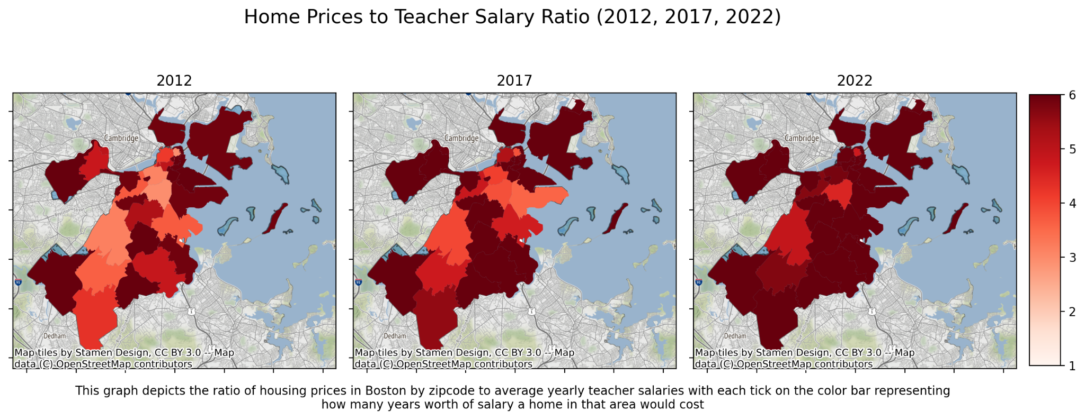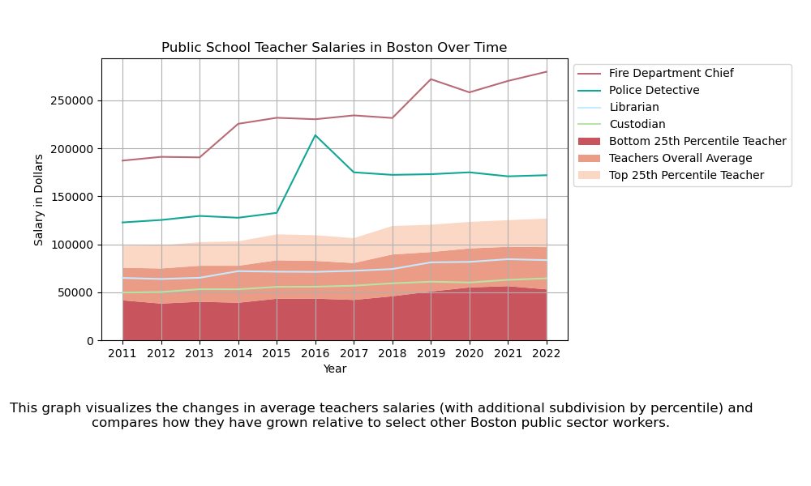

Our third visualization highlights how the average teacher's salary has grown over time relative to the average single-family home price in Boston and predicts how this trend will continue into the future. It also contains two lines at 3 times and 5 times the average public school teacher's salary, which are the two separate rules of thumb we incorporated for the affordability of buying a home. As the visualization shows, until early 2012, a teacher could still afford to buy the average single-family home if they really stretch their salary to afford one 5 times more than they make a year, but that was a long time ago. The unfortunate truth seen in the visualization is that the growing cost of single-family homes has far outpaced the wage growth of teachers. In 2022, the average price of a single-family home is now about $730,000 while the average salary of a teacher is just under $97,000. This means that from 2011 to 2022, the average price of a single-family home has increased by 92% while the salaries of teachers only increased by 29%. Sadly, our regression analysis points to this trend continuing, with the average price of a single-family home in Boston expected to reach $900,000 in 2027, while teacher salaries will have grown to only around $110,000. We expected that the price of single-family homes would likely be increasing faster than teacher's salaries; however, we had no idea that the difference would be so astronomical.

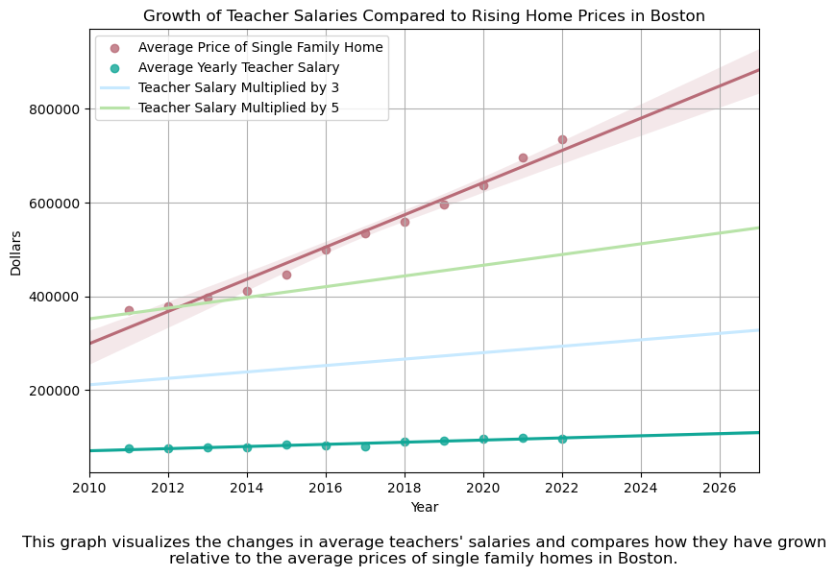

Conclusions

Through our research, we have reached significant conclusions that address our initial research questions. Our findings clearly indicate that teachers in Boston are being priced out of the city, making it impossible for them to achieve what we define as the "American Dream" within its boundaries. The rapidly rising home prices, coupled with the comparatively stagnant teacher salaries highlighted in our third visualization, indicate a trend that will continue to worsen over time, rendering it increasingly unfeasible for teachers to buy a home within the city.

This concerning trend is further emphasized by our second visualization, which illustrates the diminishing areas within the city where teachers can realistically afford to live based on financial analysts' recommendations. The available options are shrinking, and even within these limited areas, teachers still face unreasonably high housing costs. Considering the numerous colleges and school districts throughout the city, the scarcity of affordable housing is particularly disheartening. As a consequence, teachers may have no choice but to endure long commutes from residing outside the city, if they aren’t forced to give up on the dream of owning a home entirely. It is unacceptable that Boston fails to provide affordable housing for one of the most valuable professions, hindering teachers' ability to enjoy a decent quality of life within the city.

The lack of appreciation for such an essential profession is further highlighted when comparing teacher salaries to those of other public professions. Teaching requires years of education and hard work to educate the youth and contribute to our society. While we acknowledge the importance of librarians and custodians, it is unreasonable for teachers, who fulfill such a crucial and demanding role, to receive similar—and often even lower—salaries. Teachers are consistently undervalued and underpaid, which prevents them from sustaining the type of lifestyle that one might expect from all their hard work, let alone fulfilling their dream of homeownership within the city whose future they sacrifice so much for.

While our research has yielded compelling results, we acknowledge certain limitations in our study. Our calculations focus on the purchasing power of a single teacher's income, whereas in reality, many individuals who attempt to buy a house have a partner with whom they can share the costs. Although we lack data on the joint income of married Boston public school teachers, even assuming they are married to someone with a similar income, it remains relatively unfeasible for them to own a home in the city. Even when the available salary to the couple is double that of the average teacher’s salary, that would leave them with $194,000 in 2022 and a projected $220,000 in 2027. With the cost of a single-family home being $730,000 in 2022 and projected to rise to $900,000 by 2027, this represents a home-price to couples salary ratio of 3.8 in 2022 and 4.1 in 2027, showing that even the purchasing power of two teachers soon won’t be able to keep up with rising housing costs.

Furthermore, it is important to recognize that both within the teaching profession and other professions, there are individuals who, for various reasons, have only one source of income at their disposal, such as single parents. These individuals should not be deprived of the opportunity to reside in the city due to excessive housing prices. It is unjust to penalize them for working in such vital professions.

Author Contributions

*Amir*

Cleaned and processed the Boston_prop_data for years 2012, 2017, and 2022 as well as the Boston zip code .geojson file. Played an integral role in creating the Housing Prices to Teacher Salary heatmap, such as ideating the approach, generating the final visual, etc. Contributed to the general creation of the report, including writing the *Housing Prices to Teacher Salary Ratio* portion in the “Data Sources and Methods” section of the report. Assisted in the creation of the poster, as well as presented on the first day of project presentations. Aggregated the databases utilized for the heatmap and regression visualizations to prepare our project for submission.

*Emily*

Played a pivotal role in crafting essential sections of the final report, including writing the introduction, and the conclusion, and co-writing the abstract and analysis with Dimitar, making significant contributions to their development. Ensured that these sections effectively conveyed the purpose, scope, and key findings of our research, leaving a lasting impact on the overall report. Contributed valuable ideas and insights, shaping the design and concept of the heatmap visualization, in addition to providing crucial technical assistance, to bring the heatmap to life.

Presented the project on the first day of presentations, as well as assisting in the creation of the poster.

*Dimitar*

Handled all data processing and aggregation related to Boston public employee data used for all visualizations. Additionally documented everything related to this processing in the “*Public School Teacher Salaries Over Time*” section in the “Data Sources and Methods” part of the report. Also co-wrote the abstract and analysis sections with Emily. Provided general assistance and support to Emily in writing the report. Also performed all data processing and coding needed to create the “Public School Teacher Salaries in Boston Over Time” visualization. Also contributed to the creation of the poster and presented the project on the second day of presentations.

*Kamil*

Utilized a variety of SQL tools such as sqlite3, DBeaver, and csvkit in order to calculate the yearly averages of home prices in Boston. Performed all data calculations and programming needed to create the *“Growth of Teacher Salaries Compared to Rising Home Prices in Boston”.* Wrote sections of the report such as the section titled *“Growth of Teacher Salaries Compared to Rising Home Prices in Boston”* under Data Sources and Methods and the Analysis for the third visualization. Presented the project on the second day of presentations.

References

1. “How Much House Can I Afford?” *Fidelity*, 1 June 2022, www.fidelity.com/viewpoints/personal-finance/before-buying-house#:~:text=The%20total%20house%20value%20should,much%20debt%20you%20currently%20have.
2. Knueven, Liz. “Here’s Exactly How Much House You Can Afford on a $50,000 Salary, According to a Financial Planner.” *Business Insider*, 14 Apr. 2021, www.businessinsider.com/personal-finance/formulas-buy-affordable-house-2021-4.
3. “Employee Earnings Report.” *Analyze Boston*, data.boston.gov/dataset/employee-earnings-report. Accessed 22 June 2023.
4. “Property Assessment.” *Analyze Boston*, data.boston.gov/dataset/property-assessment. Accessed 22 June 2023.
5. “List of the Largest School Districts in the United States by Enrollment.” *Wikipedia*, 30 Apr. 2023, en.wikipedia.org/wiki/List_of_the_largest_school_districts_in_the_United_States_by_enrollment.
6. U.S. Department of Labor, State Minimum Wage Rate for Massachusetts [STTMINWGMA], retrieved from FRED, Federal Reserve Bank of St. Louis; https://fred.stlouisfed.org/series/STTMINWGMA, June 22, 2023.
7. McLoud, Shannon. “I Get Paid for 180 Days of Work Each Year, but I Actually Work More than 250.” *We Are Teachers*, 16 Dec. 2022, www.weareteachers.com/teacher-overtime/.
8. “ZIP Codes.” *Analyze Boston*, data.boston.gov/dataset/zip-codes. Accessed 22 June 2023.
9. Newsroom, WBUR. “Boston City Council Oks 29 Percent Pay Raise, over 6 Years, for Detectives.” *WBUR News*, 25 Feb. 2016, www.wbur.org/news/2016/02/25/boston-city-council-oks-29-percent-pay-raise-over-6-years-for-detectives.
10. Irons, Meghan E. “Police Detective Tops Boston’s Payroll with a Total of over $403,000 - The Boston Globe.” *The Boston Globe*, 14 Feb. 2017, www.bostonglobe.com/metro/2017/02/14/police-detective-tops-boston-payroll-with-total-over/6PaXwTAHZGEW5djgwCJuTI/story.html?s_campaign=bdc%3Aarticle%3Astub.